**Group Three Project Report: Cultural Map of Edinburgh**

Group members:

Xinyan Chai, Yeru Lin, Ziyu Yang, Wenyun Deng, Zihan Yuan

Data-holder: Currie Morgan

Video: https://www.youtube.com/watch?v=homO5TfpdJM&feature=youtu.be

Webpage: https://linyeru.github.io/Map/index

**Introduction**

Edinburgh is a city with a rich cultural history. In our challenges, we looked at the cultural data of Edinburgh and got the data on the website: <https://www.edinburghculturalmap.org/>, which includes the datasets of bus stops, care homes, festivals, nursery schools, public art, street art and so on. We chose to conduct a detailed analysis of the art of Edinburgh from the public art datasets. Our group used python and ArcGIS to do the data analysis. Then we combined a physical map and digital interactive website to present different parts of public art in Edinburgh including timeline, geographical distribution and type sorts. In this way, we hope our audience can have a general understanding of the development of public art in Edinburgh and raise their interests in exploring public art in the city by interacting with the physical map.

**Context**

According to Andrew, public art is place-based and represents local history, which could serve as gathering places and promote collective memories (Zitcer and Almanzar, 2019). Public art visualizations could help people understand the public art, foster relationships between individuals, communities and the environment. Visualizations of cultural data at Edinburgh have had various design precedents. Previous predecessors have produced virtual tours and flaneurs for the city (The Edinburgh Culture and Community Mapping Project, 2020). We propose that a combination of a physical piece and interactive installation might accompany those visualizations and create another dimension for the projects. We found maps to be a good way of showing the position and give an overall view of the city. Some cultural data sets offer insights into the different cultural aspects for the city to construct our representation for the public art at the city.

**Data analysis**

The datasets we chose to use are public art and street art with CSV format. These datasets conveyed the detailed information of arts in Edinburgh, for example, date, type, images and so on. Due to too many messy data in the documents, we first needed to clean the data with Pandas and Numpy.

For showing the timeline of different arts in Edinburgh, we needed to deal with the date column firstly. The date in public art.csv was complex with different formats, like some showing date with '/', while others showing with '-'. We solve this problem by using the functions of strip and split. In addition, we had several missing data in date both in public art and street art, which meant we need to filter them.

In order to show the details of public art time and space distribution, we only kept the columns of position and date information. Connecting two files is vital to make our data more readable. Also, we output the files according to different construction centuries to show the timeline and position information more clearly. As for type part, we kept the only type column in public art to see the type categories.

We used Python’s libraries of Pandas, Numpy, Matplotlib, Folium and Wordcloud to analyze the public art data from 3 different aspects, including the development of public art over time, geographical distribution and type sorts. Our key findings are shown below.

We found that, in general, there is 152 public art in Edinburgh in total. The earliest one existed in 1685, called ‘Charles II’, which has a history of more than 300 years. Four public art existed in 2020, including ‘Scotland, together, persevere, NHS’,’ Free Speech’, ‘Unity’ and ‘The Protest’. After that, we analyzed more details about the development of public art in Edinburgh over time. It is illustrated by the pie chart (figure 2), the 20th century saw the most public art established in Edinburgh, accounting for 40.1%. While public art before the 19th century made up only 1.3% of the total. From the 18th century, the number of newly established public arts increased during each century. Although it is only the first decade of the 21st century, 43 new public art projects have been created, accounting for 28.3% of the total.

In addition, our group tries to explore how public art in Edinburgh is distributed spatially. As it shown in the geographical distribution heat map (figure 3) and the location scatter plot (figure 4), public art is not evenly distributed in Edinburgh and there are some areas where the density of art is huge and some areas where the density is scarce. To be more specific, it could be seen that public art is mainly concentrated in the city center area in Edinburgh.

Finally, for the type of public art, the data set offers us detailed information about the types of public art. Using Wordcloud in python, we find that Edinburgh has a wide variety of public art in figure 5, mainly including sculpture, sculpture group, statue, stone and monument.

**Target Audience**

We identify our audience to be visitors to Edinburgh. By interacting with the entity, we hope to raise people’s interests and encourage them to further explore the public art in the city, finding their own serendipity of art encounters when wandering in the streets, and getting immersed in the art atmosphere of this city.

**Prototype**

After the data analysis, we decided to design a prototype which combines the physical map and digital interactive screen to show the audience different aspects of public art and provide an informative and engaging experience for our audience.

Physical map:

The physical map mainly consists of three parts including public art space distribution heat map, time distribution pie chart and a map showing the location and time of each public art in the city center. We use the laser cutting to customize the shape of the boards and layer boards to give more variations of our physical map.

In the upper left corner of the entire object is the geographical distribution heat map, which shows the distribution and spatiality of public art throughout Edinburgh. We chose to use plasticine of different colors to physicalize it and overlay it to make the map more intuitive and three dimensional. Different colors of the plasticine represent the different density of the art in the city, while the red represents the most art-dense place and the blue represents less art-dense place. Time distribution pie chart is on the right corner. Through layering up different amounts of boards, this three-dimensional pie chart shows different proportions of public art built over the centuries and the audience can have a more intuitive experience of the establishment of public art in Edinburgh.

The map of the Edinburgh city center is the most important part of our prototype. Since finding the public art is concentrated in the city center area of Edinburgh, we enlarged this area and displayed the details of every public art in this place through the combination of physical objects and interactive screens. We use different height and color of the sticks to represent the year range of different public art. The longer public art exists, the longer stick will be. It helps the audiences understand how different public art develops in the city center. When people touch the top of the sticks, the interactive screen will show the detailed information about this art automatically.

Interactive screen:

Our interactive screen is a dynamic website. The website mainly consists of 3 parts including physical map introduction, interactive timeline, and some visual diagrams related to public art. In the first part, audiences can first get an overview of our interactive map through the introduction and instruction on the site. In the second part, the public art timeline will change as audiences touch different sticks on the physical map. They can also click on the name of the artwork on the timeline to see the picture and information by themselves. At the end of the webpage, we also presented some visual diagrams related to public art. Through using the web technology, people can zoom in and zoom out the heat map to explore more which helps them have a better understanding of the spatial distribution of these artworks, and can also relate them to some geographical or cultural environment. They can also click on the chart to see some detailed information.

**Summary & Reflection**

Using data analysis we find that public art in Edinburgh is very rich and has a long history. We design the prototype which combined the physical map and digital interactive screen to convey the messages for the travellers in Edinburgh. Try to show them the specific information of time, space distribution and types categories. The interaction between physical map and digital interactive screen raise people’s interests in Edinburgh arts and learn more about Edinburgh culture.

In the future, our prototype needs more improvements. First of all, considering the cardboard size limitation, we only show the public art in the city center in detail. Then we can extend it to the entire Edinburgh area. In the second, We just make the prototype to link the screen to our physical map. We hope to do further work like using the Arduino to make it become a reality. In addition, there are still some missing data for the existing year of the public arts in the data set, which need further exploring.

**Reference**

Edinburghculturalmap (2020) *The Edinburgh Culture And Community Mapping Project*. Available at: https://www.edinburghculturalmap.org/research (Accessed 6 December 2020).

Zitcer, A. and Almanzar, S. (2019) 'Public art, cultural representation, and the just city'. *Journal of Urban Affairs*, 42(7), pp.998-1013. doi: 10.1080/07352166.2019.1601019

**Appendix**

Figure 1 The amount of arts for different years

*Note*. The amount of arts for different years shows the general number of arts in different years.

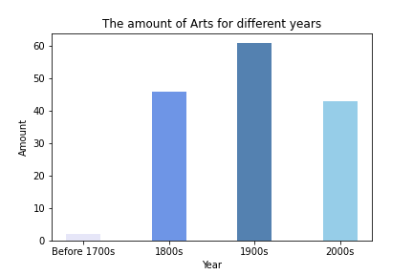

Figure 2 Year of art distribution

*Note.* Year of art distribution shows the proportion of arts in different centuries.

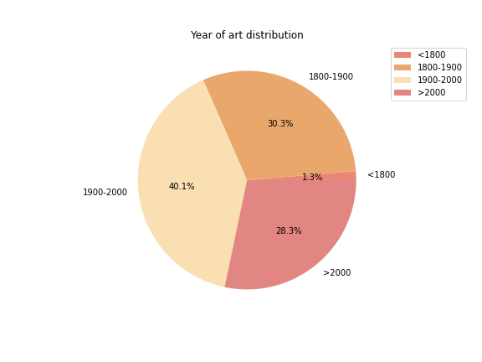

Figure 3 Public art heatmap

*Note.* Public heatmap shows the space distribution with colours.

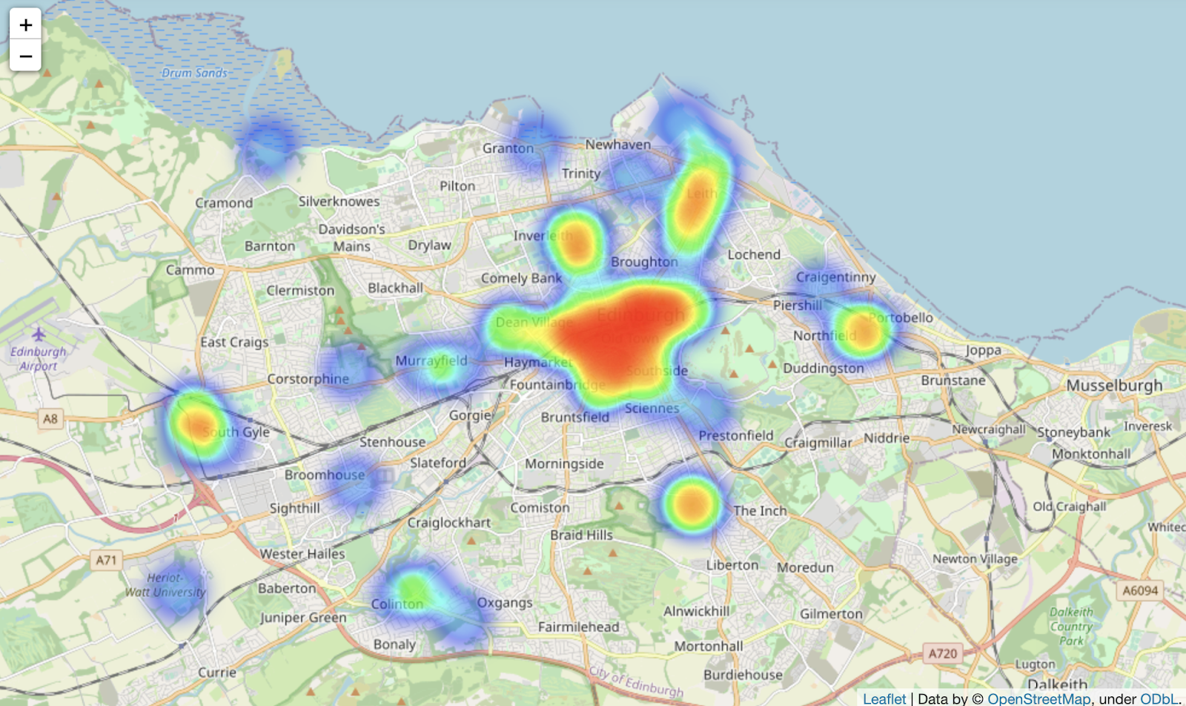

Figure 4 Art position distribution

*Note*. Art position distribution shows the general positions information of arts in different centuries.

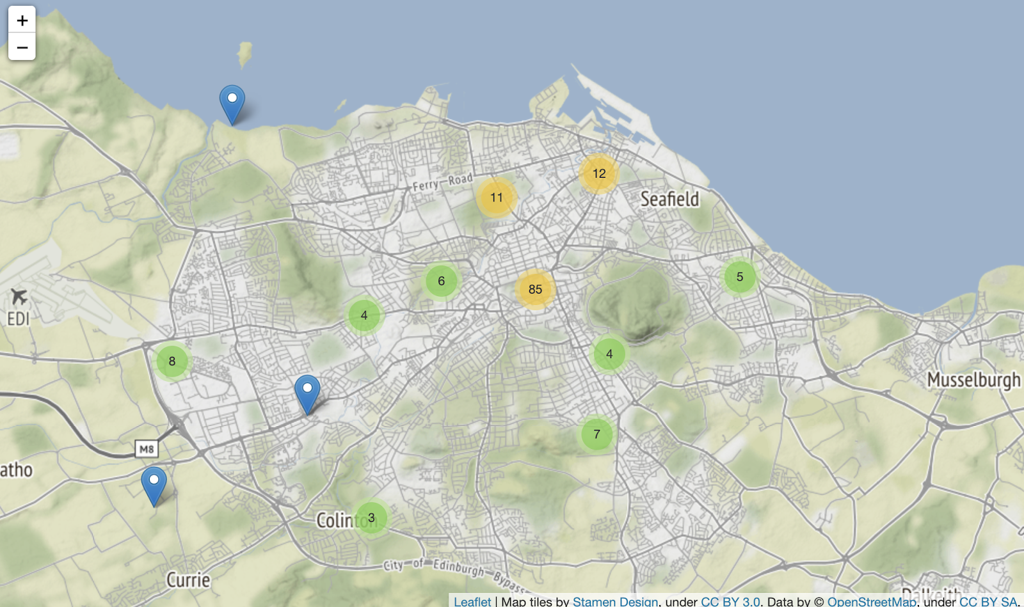

Figure 5 Wordcloud for public arts type

Note. Wordcloud for public arts type shows the most frequent use public arts type in Edinburgh.

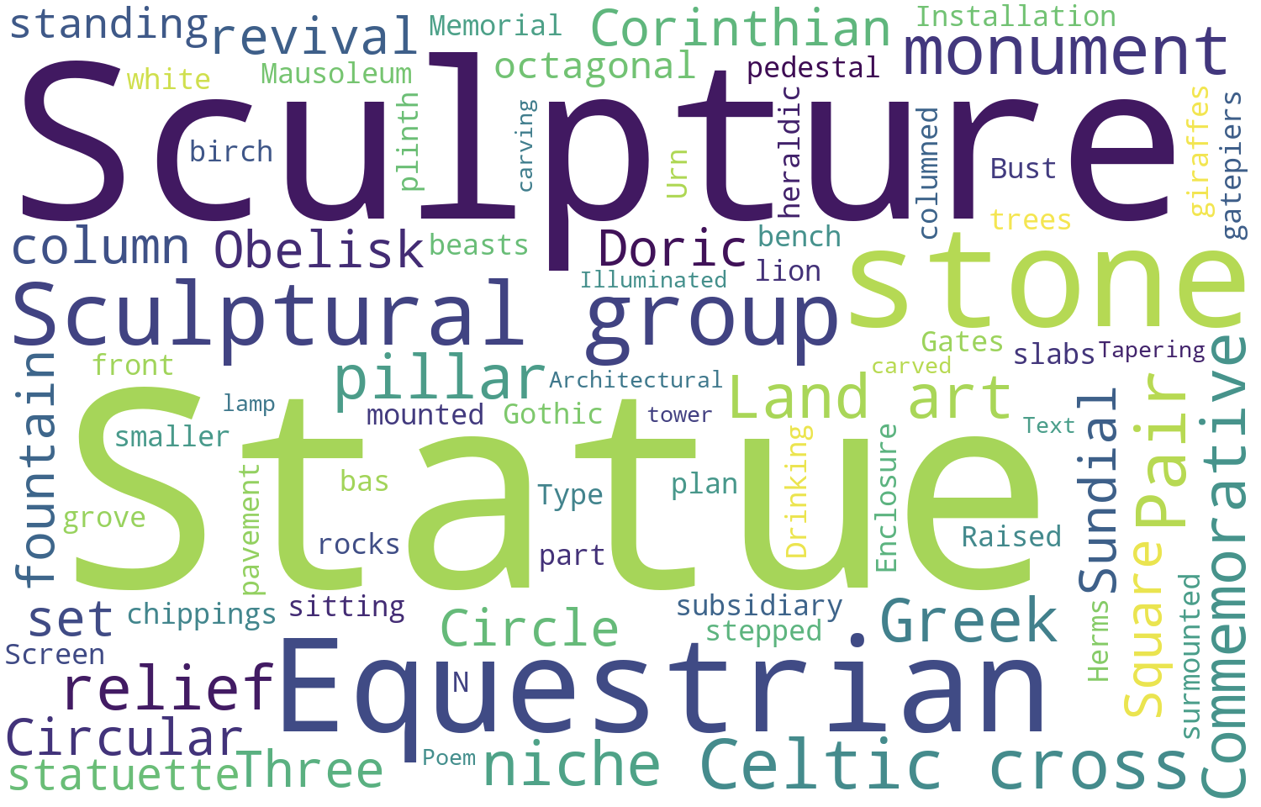

Figure 6 Location scatterplot

*Note.* Location scatterplot shows the different public arts in Edinburgh’s space distribution.

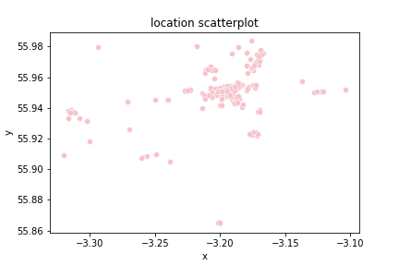

Figure 7 The appearance date distribution

*Note*. The appearance date distribution shows the year distribution for arts.

